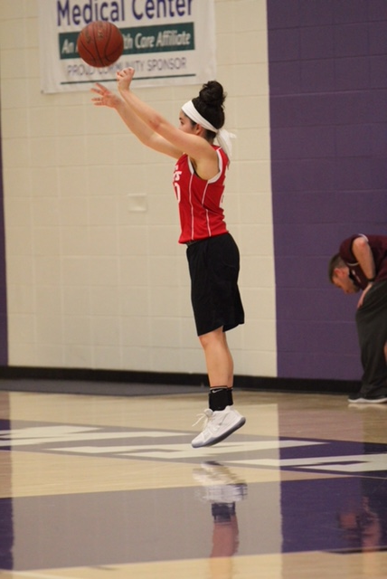
Patient Spotlight of the Month!
Zoe S
After hearing so many amazing things about Dr. Christa and not making any improvements with my injury, I called to get in right away. During my 7th grade basketball season at Bothwell Middle School, I sprained my ankle in a game very early on in the season. I went to the doctors, and they told me I had a high ankle sprain and that I was going to be put in a boot until my next appointment which was in two weeks. After countless visits to my doctor’s office I was not getting better at all. I was non-weight bearing for 8 weeks still in so much pain. After one of my appointments, I told my mom we needed to go for a second opinion, because I knew something was not right. She called down to Green Bay to their top orthopedic doctor and got me in as soon as she could. My mom and I made many day trips down to Green Bay. I went through lots of different tests because they couldn’t tell exactly what was wrong. The doctor gave me a cortisone shot to see if that would bring the inflammation and pain level down. They sent me back about 3 weeks later with no improvement. He told me that it was time for surgery. I found out I was going to be having surgery on a Tuesday and was back down on Thursday. With me having surgery on February 2, 2017, and my 8th grade basketball season starting in August, I knew I had a very long road of recovery ahead.
I have been seeing Dr. Christa and Ryan for a little over a year and not quite sure if I would have been able to play my 8th grade year if I wouldn’t have gone in to see them. Being in a boot for 6 months caused me to lose all my muscle in my right leg from my hip all the way down. I had to strengthen my whole leg and retrain myself how to walk properly. I have made so much amazing progress from going to Horizon Healthworks. Dr. Christa and Ryan have done many different treatments on me. Including, ultrasounds, underwater ultrasounds, electrical stim, and they both have done manual muscle work. One of the biggest goals I had when I first started go to Dr. Christa’s office was getting back to playing basketball and getting ready for the season coming up. Getting my footspeed back to normal is my new goal for this basketball season. I’m so thankful that I was able to find Dr. Christa she is so amazing and helped me through a very tough time in my life and continues to help me now.

