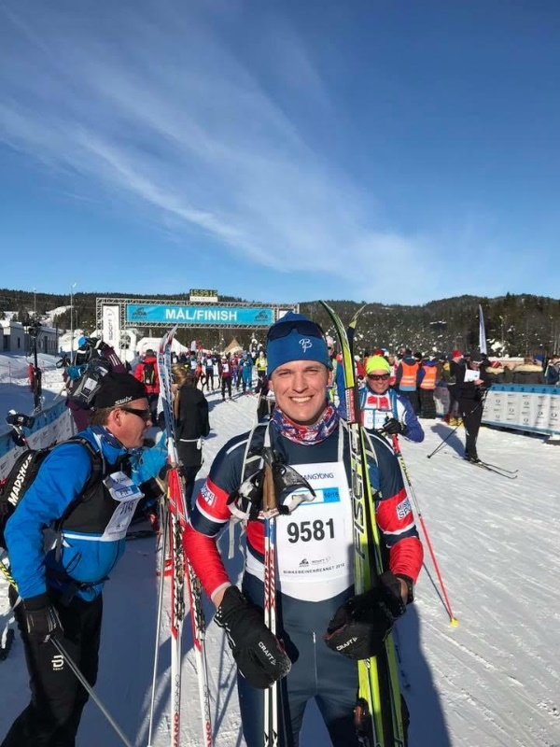
Patient Spotlight of the Month!
Alex L
While playing Juniors (hockey) in Ontario, Canada, I unfortunately suffered a relatively severe concussion in 2012. During a game, I was illegally hit and flipped, landing inverted on my head, compressing my spine. I was knocked unconscious and only have vague memories from the event. I started to regain consciousness and memory while being transported to the hospital in an ambulance, strapped to a backboard and in a neck brace.
Since I was in Canada as an American and not covered by their health system, they would not examine me with the proper tests that I or anyone would receive in an American ER. No X-ray, no MRI, no CT, no concussion protocol testing, nothing - even though I had been unconscious for quite a while and could very well have had a neck injury. Instead, the doctor lightly palpated my neck, gently rotated my head, then concluded I was fine. He recommended only that I rest for a couple of days before resuming play.
As a very serious competitor, I was happy the doctor had cleared me to play after only a couple days rest. I took the advice, rested a couple days, then went back on the ice with full contact even though I wasn’t feeling well. I was experiencing nausea, headaches, migraines, dizziness, memory loss, light and sound sensitivity, etc. I even felt a very uncomfortable sensation of my brain rattling inside my head while playing. However, since the doctor told me I should be fine, and since I desperately wanted to play, I fought through the symptoms and carried on. At this time, I was also being recruited to play collegiately, so I felt I needed to play to obtain a scholarship.
About two weeks after my injury, I played in my first game back. I have very little recollection of the night, but luckily my coaches and team doctor were monitoring me attentively. They pulled me from the game about halfway through as they could clearly see I was seriously not well. I’m lucky and grateful they had monitored me so intently and put my health and wellbeing first.
My symptoms continued to worsen. I developed a severe stutter in my speech, I couldn’t connect thoughts to words, headaches were worsening, and I even experienced a few seizures. At this point, my coaching staff sent me home to Marquette to seek treatment. The first specialist I saw while home ran the appropriate diagnostic tests. She told me I was lucky to be alive, as it could have been fatal to undergo the trauma I had continued to experience to my already injured brain, while playing. She sadly told me my hockey career was finished and that it was time to rest and try to recover.
Right around this time, a friend of mine had heard about my injury so he recommended I go see Dr. Hubbard. My first appointment with Dr. Hubbard was like nothing I’ve ever experienced. She was able to investigate areas of my brain other specialties and examinations hadn’t been able to look into. She was also able to find issues in regions of my brain that had been overlooked. After her thorough examination, she began rehabilitative exercises and after just the first appointment I was already starting to see improvement. Most importantly, I regained hope that I would be able to recover. Now, several years later, I no longer experience most of those symptoms I once suffered from and the symptoms I do still experience are minor and non-debilitative like they had been. I’ve been able to successfully go back to school and become active once more - now partaking in endurance sports and competing in Nordic Ski marathons.
Throughout my recovery, I continued to gain interest in the brain and healthcare in general. I even job shadowed with Dr. Hubbard for a while. Not long after working with Dr. Hubbard, I was able to start undergraduate school at Northern Michigan University and my passion for a career in hockey had converted to a passion for healthcare. Dr. Hubbard not only helped me significantly recover, but she also helped guide me throughout my undergraduate degree and was monumental in my acceptance to medical school at Michigan State University’s College of Human Medicine, where I will begin in August.
Dr. Hubbard and all staff at Horizon, past and present, have helped give me another chance at a healthy life and an opportunity to positively impact the lives of others, as they have impacted mine. I’m inexplicably grateful for them and feel so lucky to have this practice in our community. Thank you, Dr. Christa Hubbard and all Horizon HealthWorks staff!

