Patient Spotlight of the Month!
Suzanne S.
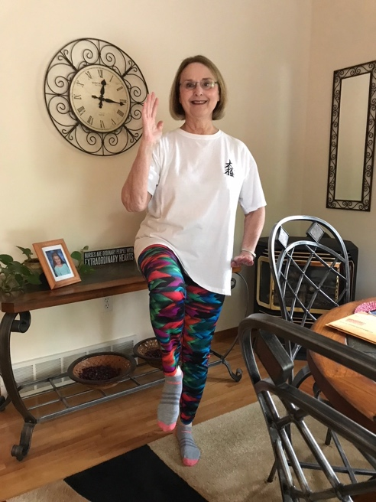
I have been treated by Dr. Christa for about four months. I began on the recommendation of the surgeon who performed two minor surgeries on my feet. I expressed concern that I was unable to complete Tai Chi poses requiring I stand on one foot even after two years of classes. The surgeon stated that Dr. Christa is a “miracle worker” and could help me improve my balance. He was certainly right!

At the same time, I began seeing Dr. Christa, I was also told by a neurosurgeon that I required a complete spinal fusion with additional procedures due to my progressive scoliosis and additional complications. Across my life, I have had issues with balance and coordination that I believe are due to the scoliosis, which includes lateral “S” curves, twisting of the spine, and hip and shoulder elevation on the right side. As we began working together, Christa quickly assessed my balance issues, thoroughly considered recent x-rays and MRIs, and diagnosed how my movements were affected by both the scoliosis and limited movements of my eyes and limbs. She thoroughly explained what she saw and how we should begin treatments. I was fascinated and motivated by the explanations that helped me better understand my own issues.

However, not only did we need to work on my balance issues, but I also wanted to be in the best physical condition possible before I saw the specialist spinal surgeon to whom I was referred. So, Dr. Christa devised a plan to improve my balance as well as to alleviate as much back, neck, leg, and hip pain as possible in preparation for traveling to see the surgeon. She assessed my pain levels, muscle tightness, and movement twice per week for two months. She provided an exercise regimen for me to follow at home and checked my questions and progress each visit. She then used a range of gentle manipulation, heat therapy, and ultrasound to decrease pain levels. By the time I went for my surgical appointment, I was nearly pain free and was able to travel comfortably despite the eight hours of travel each way. Before seeing Christa, an eight-hour drive, even with frequent stops, was extremely difficult for me. Luckily, the surgeon decided he would not do the surgery at this time because I was doing so well with movements, strength, and pain level. He recommended I add some physical therapy for core strengthening and a series of epidural spinal injections to augment what I was already doing. Such good news was at least in part due to the treatments from Dr. Christa.

Now, four months after beginning treatments with Dr. Christa and following the recommendations of the surgeon, I am functioning very well. I have partially achieved my original goal of being able to do the one-leg stances in Tai Chi. I need to continue improving the ways in which I use my right leg. My pain level is vastly better than it was. If I arrive for an appointment with an area that has tightened up again, Dr. Christa uses her skills to relieve the tightness and the pain, and I leave feeling much better. I am so thankful to have found Dr. Christa and will continue working with her to maintain and continue improving. Working with her is pure joy because she is so pleasant, and I always leave better understanding my issues. I feel in control and able to continue improving under her direction. Thank you, Dr. Christa.

